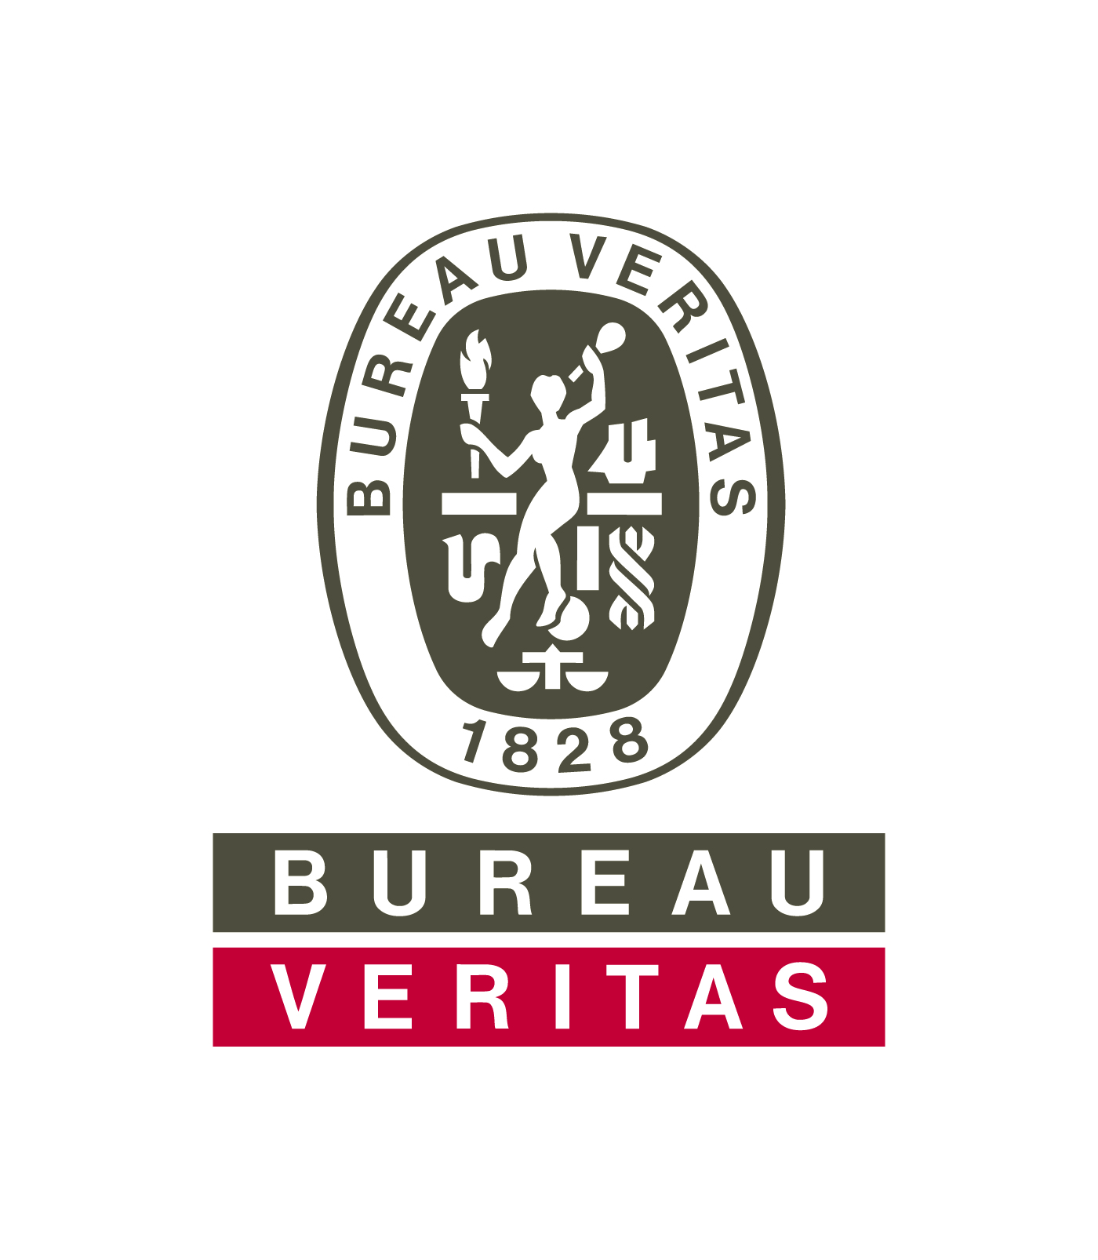

‘‘Keep Food Containers Safe from PFAS Act of 2021’’ Bill Proposed in US Senate

A bill has been proposed in the United States Senate (S.3169), called the ‘‘Keep Food Containers Safe from PFAS Act of 2021.’.

The purpose of the proposed bill is to amend the Federal Food, Drug, and Cosmetic Act, by prohibiting food packaging containing intentionally added PFAS, from being introduced or delivered for introduction into interstate commerce.

If passed, the Federal Food, Drug, and Cosmetic Act (21 U.S.C. 331) would be amended by adding the following:

(fff) (1) The introduction or delivery for introduction into interstate commerce of food packaging containing intentionally added PFAS.

‘‘(2) The term ‘PFAS’ means a perfluoroalkyl substance or a polyfluoroalkyl substance that is man-made with at least 1 fully fluorinated carbon atom.’’.

The amendment will be effective beginning January 1, 2024, if it becomes enacted.

Additional Information:
https://www.congress.gov/117/bills/s3169/BILLS-117s3169is.pdf

How Does this Impact You? Contact Us to Discuss
Bureau Veritas can help you ensure that your products will meet your customer’s expectations as well as all applicable regulations. We can help you reduce cost and time-to-market, minimize the risk of recalls and returns, increase sales and customer satisfaction, and eliminate previously unidentified threats to your company’s reputation. Our services help protect both your bottom line and your peace of mind.

If you have any questions on these final rules, please contact your customer service representative or email: cps.info@us.bureauveritas.com

Bureau Veritas Consumer Products Services, Inc. (“BVCPS”) provides the information in this client bulletin as a resource of general information. It does not replace any applicable legal or regulatory requirements and is provided “as is.” BVCPS will not be liable for any indirect, special, punitive, consequential or other damages (including without limitation lost profits) of any kind in connection with this client bulletin. BVCPS DISCLAIMS ALL REPRESENTATIONS AND WARRANTIES, EXPRESS OR IMPLIED, INCLUDING WITHOUT LIMITATION WARRANTIES OF MERCHANTABILITY AND FITNESS FOR A PARTICULAR PURPOSE, IN CONNECTION WITH THIS CLIENT BULLETIN.

Copyright © 2021 Bureau Veritas Consumer Product Services, Inc. All Rights Reserved. November 2021, 20B-122

